#APuffAin’tTuff– Campaign Toolkit and Resources
City of Greater Dandenong Youth and Family Services
What is #APuffAin’tTuff?

#APuffAin’tTuff is a health promotion campaign designed by members of the 2025 Young Leaders Program, targeting local young people with evidence-based messaging aimed to reduce the prevalence of vaping in the community. The aim of this campaign is to challenge local young people’s beliefs about the perceived benefits of vaping and ultimately reduce the rate of harm that young people experience because of vaping.

This campaign comprises of three key images, which have been reproduced as posters, stickers, social media posts and will be distributed throughout the community, and through Council’s promotional channels. Each of these three images explores a key message curated by the Young Leaders. This toolkit has been designed to help you share this campaign and prompt discussions with young people in the community around the role of vaping in their lives. Included in the toolkit are:
- A classroom discussion guide for each of the three campaign images
- A social media toolkit with images and accompanying captions that can be shared through your social media channels
- Additional resources for schools, parents and young people

You can read more about the project on the Youth and Family Services website: #APuffAin’tTuff | Youth
Contact
If you have any questions or require further information about the #APuffAin’tTuff project, please contact the project officers listed below:

Matilda Houlihan (she/her)  Youth Planner and Engagement Officer  Matilda.Houlihan@cgd.vic.gov.au  T | 8571 1620 | Venushi Dewundege (she/her)  Youth Development Officer  Venushi.Dewundege@cgd.vic.gov.au  T | 8571 1620

Testimonials from the creators of the campaign – 2025 Young Leaders
“It was a great experience I loved working with everyone and learning from others’ ideas to improve my original idea. I feel proud of myself as it feels like I am contributing positively to the community.”

“This project was exactly the kind of work I enjoy, so I was excited about it from the very beginning. I really valued collaborating with everyone and seeing how our different skill sets came together to create something meaningful. It felt like I was part of something bigger, and I’m genuinely proud of what we achieved as a team.”
“I loved creating the vape campaign project as it allowed me to grow more aware of the ingredients used in vapes and especially the perspectives the majority of people have in how many people vape, when in reality most young people do not vape. I loved learning about addressing the target audience correctly as well as sticking to the right tone.”

Project Background
Council’s Youth and Family Services worked to develop this campaign with the 2025 Young Leaders, a cohort of 25 local young people who completed our flagship leadership development program. They created #APuffAin’tTuff as a major project during this program, developing important skills in health promotion, communication and social marketing, and evidence-based practice. They learned about the most up-to-date research from VicHealth, including what kind of messaging is most effective in reaching young people about vaping, statistics about the prevalence of vaping in our community, and impacts and harms of prolonged vape use. The young leaders then workshopped campaign ideas and developed a design brief which was provided to a local designer, who created the final campaign images that form this social media campaign / toolkit.

The #APuffAin’tTuff campaign and accompanying social media toolkit are being launched in [DATE] and will be circulated to all secondary schools in Greater Dandenong and via council’s social media channels.

Evidence
Vape use is prevalent amongst Australian young people, though it is challenging to definitively confirm usage rates as different datasets report a wide variety of results. Early data suggests that rates may be reducing following the introduction of vape regulation reforms introduced in late 2024, but use remains common, with roughly 14.7% of young people aged 14 – 17 having ever tried vaping and around 5% vaping daily (Cancer Council, July 2025).

A key factor impacting attitudes towards vaping is that children and young people are being deliberately targeted by vaping advertisers, who employ a variety of tactics to appeal to young people. Pro-vaping content vastly outnumbers anti-vaping or educational content on both Instagram and TikTok, and there are at least 18,000 influencer profiles explicitly dedicated to pro-vaping content including many Australian profiles (VicHealth, 2024). When surveyed, young people were typically more able to remember the core messages of pro-vaping content as compared with educational content and described the educational content they did remember as “boring” or “lecture style” (VicHealth, 2024). For this reason, #APuffAin’tTuff brings youth voices into the conversation about vaping, creating a campaign that is engaging and speaks from the voice of a peer.

Classroom Discussion Guide

Image 1 – Don’t let vaping smoke your life
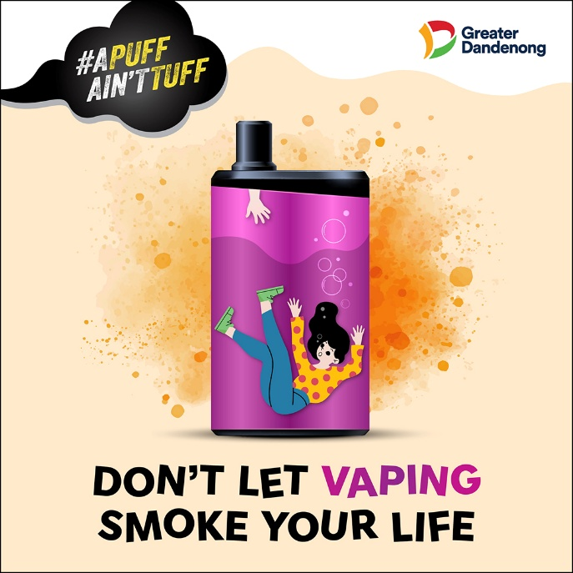
Key messages
- This image aims to highlight how easy it is to feel ‘out of control’ or like you are ‘drowning’ when it comes to vaping, how quickly addiction can form, and how it can start to take over a person’s life without them even realising.
- The image came from participants’ reflections on hearing stories from young people who started vaping “just to try” and became “hooked” in a very short period. These stories also emphasised the challenge of fighting addiction once it has taken hold, with a sense that it is very easy to start and very hard to stop.
- Another important component of this image is the hand reaching into the vape from the top to help. Participants wanted to emphasise that young people don’t have to fight addiction on their own, and that lots of help is available to pull you out of the ‘haze’.

Discussion questions
- How quickly do you think people can become addicted to vaping? Once someone is addicted, how easy or hard do you think it is to stop?
- How could being addicted to vaping affect your life? Don’t just think about the health effects.
- What could the hand represent at the top of the vape? What kind of help might she need? Do you know where she could get help if she wanted to ask for it?

Image 2 – Mirror, mirror, on the wall…

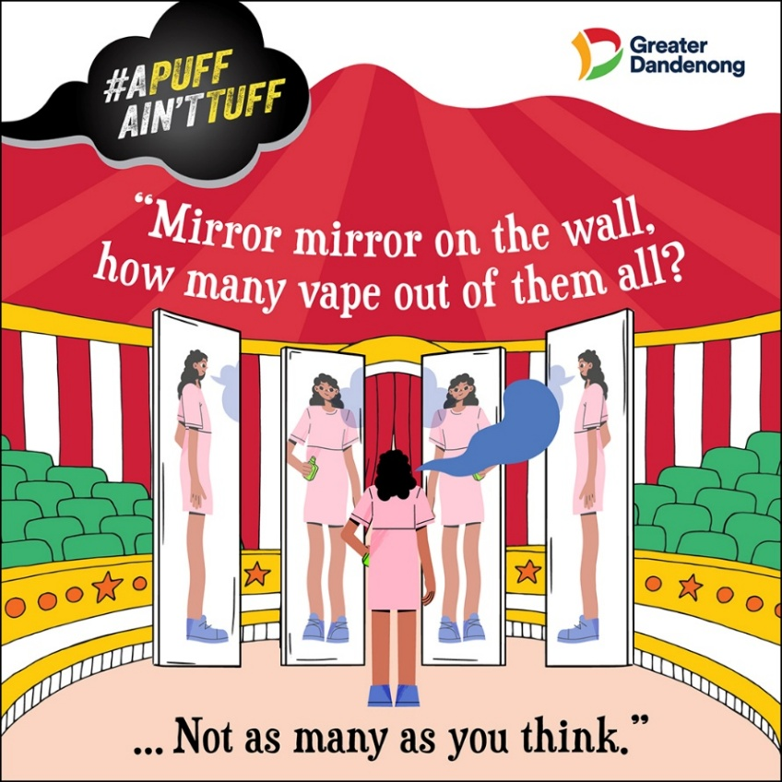

Key messages
- This image came about because of the Young Leaders’ surprise to learn that vaping was not as prevalent amongst young people as they had expected. When asked, participants estimated that anywhere between 50 – 70% of young people are vaping regularly. They were very surprised to learn that the actual rate of young people who vape regularly is around 5% for people aged 12 - 17 (Cancer Council, 2025) and around 23% amongst older teenagers (ASSAD, 2023).
- From a health promotion perspective, these rates are still higher than we would like, but the large gap between assumptions and reality suggested to the group that there might be an “imaginary peer pressure” effect occurring, where young people try vaping because they think that “everyone is doing it”, when in reality, the majority of young people do not vape.
- The image is inspired by a “hall of mirrors” at a circus, which gives the illusion of a large group of people, when in reality there is only one person at the centre of the mirrors. In the same way, the Young Leaders felt that there is an illusion of everyone vaping around them, but the number of people who vape is “not as many as you think.”
Activity: Create an imaginary line in the room, where one end of the line represents 0% and one end of the line represents 100%. Ask students to position themselves along the line, estimating what percentage of young people they think have ever tried vaping, and what percentage vape regularly. Once they have made their guesses, provide the correct statistics – check for up-to-date information via the Cancer Council’s Generation Vape research or the Australian Secondary School Students Alcohol and Drug survey.
Discussion questions
- Did the statistics surprise you? If there was a big difference between their guess and the facts, why do you think this is?
- What do you think causes the illusion that ‘most people vape’?
- What could happen if we believe that ‘everyone around us’ is vaping?
Image 3 – The choice is yours
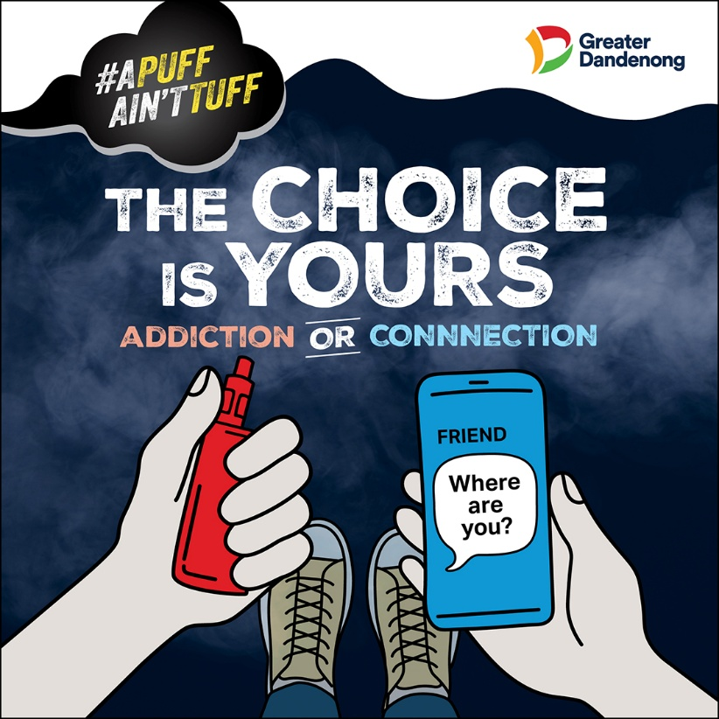
Key messages
- This image is inspired by the Matrix’s “Red pill/blue pill” scene and aims to focus on some of the potential short-term harms of vaping (rather than on the long-term health harms, which participants felt might not seem as important to young people).
- This reflects the potentially isolating impacts of addiction, with participants reflecting on experiences they’ve had of friends pulling away from social groups and becoming disconnected from the world around them as they become increasingly addicted to vaping.
- The image highlights one of the lesser-known negative impacts of vaping: even short-term use can worsen symptoms of depression and anxiety, increase stress levels, and frequent vaping is strongly linked to higher odds of depression (Truth Initiative, 2021). While some young people believe vaping helps manage stress, in reality, it often makes mental health symptoms worse.
- Participants acknowledge that vaping can be viewed as a social activity to some young people, but they hoped to highlight situations where vaping addiction has had negative mental health impacts which can result in isolation. They also hoped to contrast that connection with friends can act as a supportive force, which could be chosen instead of going down the path of addiction.
Discussion questions
- Do you think there is a connection between vaping and mental health? Do you think people who vape would have better or worse mental health?
- How could vaping get in the way of friendships?
- How could vaping help our friendships? If it could help our friendships, would it be worth it? Are there other ways to get the same social connection?
- How could friendships help us deal with problems like vaping? Would you talk to your friends if you were concerned about vaping?
- Which choice would you make?

Social Media Toolkit
The campaign includes three key images, available in a wide variety of sizes for posters, social media and display screens. You are welcome to download and share these images, as well as a campaign video, from our website: #APuffAin’tTuff | Youth.

Below are a series of suggested captions to accompany each image, if you would like to share the campaign on your own social media channels, newsletters, via Compass or elsewhere.

Please join us in sharing this project far and wide in the community!

Content/ Source | Caption
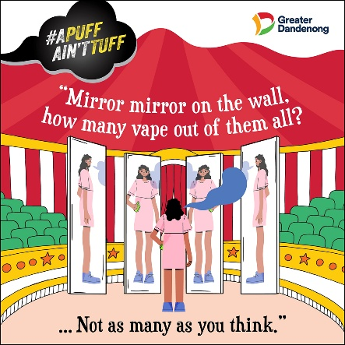 | Mirrors can be deceiving – know the real picture.  While it might feel like “everyone is doing it”, in reality around 85% of young people aged 14 – 17 have never tried vaping. Don’t buy into the hype – if you’re not vaping, you’re not alone.  Check out our website for more resources about vaping and information about how to get support if you’re concerned about vape use. #APuffAin’tTuff | Youth  #APuffAin’tTuff  Created by the 2025 Young Leaders
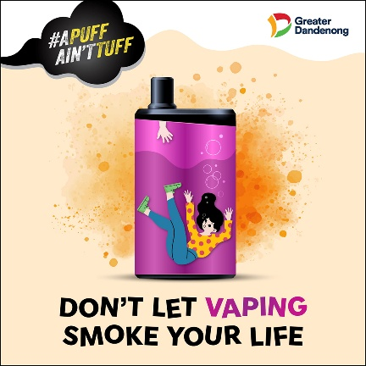 | Don’t let a vape control your story.  Some young people are curious and start vaping just to “try it out”, but addiction can form more quickly than you realise. If you’re concerned about vaping, seek help early to understand more about how to take control before it’s too late. Check out our website for more info and helpful resources. #APuffAin’tTuff | Youth  Created by the 2025 Young Leaders  #APuffAin’tTuff
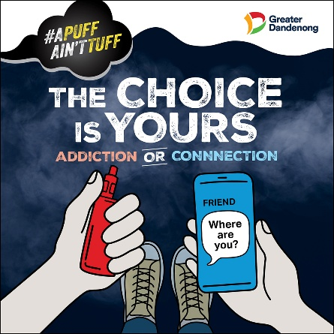 | Clear the smoke and see the real picture.  While you might think that vaping is a social activity, in reality many people who vape regularly experience increased depression and anxiety symptoms, which can lead to isolation and disconnection from those around them. The choice is yours – don’t let the smoke cloud your judgement.  Check out our website for more info and helpful resources, and help prevent vaping harm in our community. #APuffAin’tTuff | Youth  #APuffAin’tTuff  Created by the 2025 Young Leaders

ADDITIONAL RESOURCES
For Schools

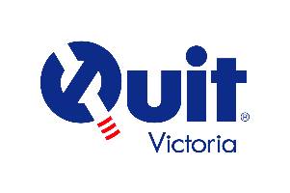 | Seeing Through The Haze: Quit’s free, evidence-based, curriculum-aligned vaping education resource that has been designed for use in school settings with upper-primary and secondary school students.  https://www.quit.org.au/about-our-education-resources
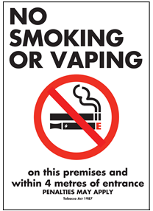 | Free “no smoking or vaping signage”: To support schools to create smoke and vape-free environments, Monash Health’s health promotion team is offering 2x free 'No Smoking or Vaping' outdoor signs to schools in Cardinia Shire, City of Casey and Greater Dandenong.  Contact healthpromotion@monashhealth.org to access your free signage.
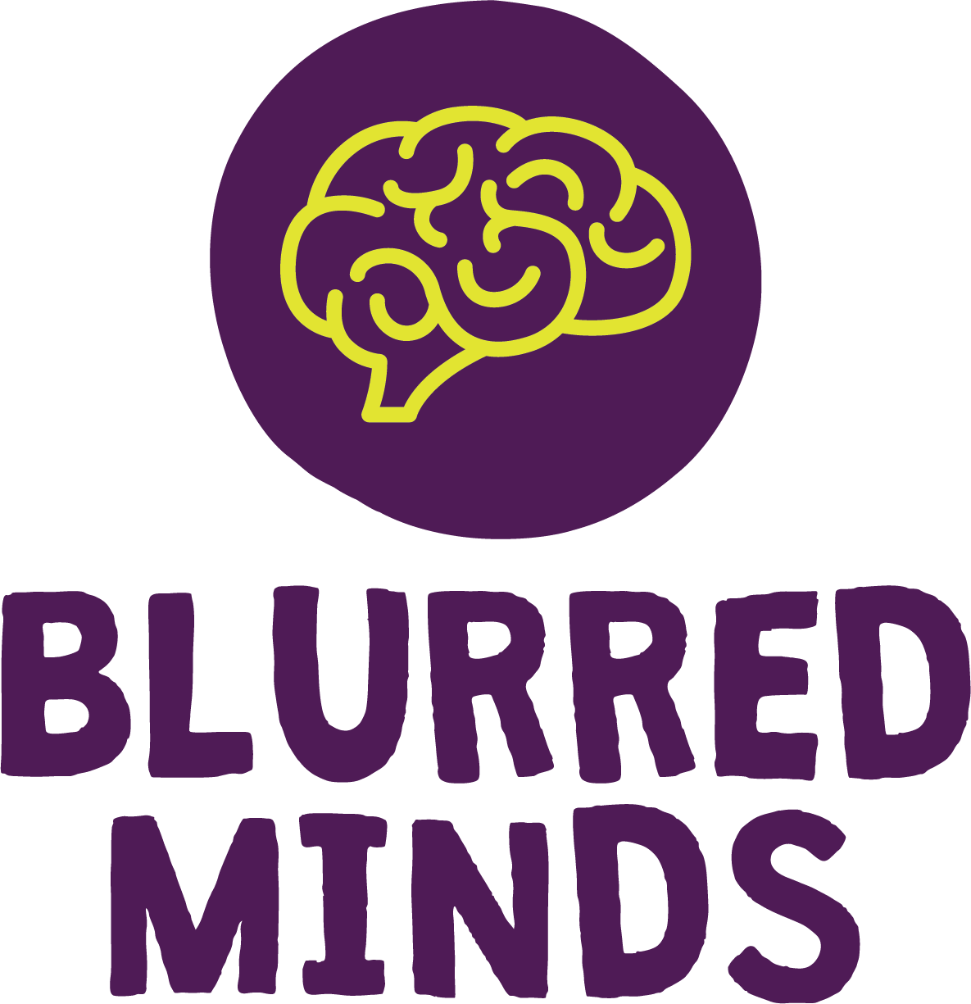 | Blurred Minds: Evidence-based substance education for schools.  https://www.blurredminds.com.au/
 | Peninsula Health Vaping and E-Cigarette Use Prevention Toolkit for Schools  https://www.peninsulahealth.org.au/wp-content/uploads/Prevention-toolkit-for-schools-Final-Dec-2022.pdf
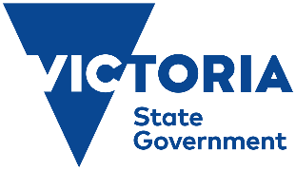 | Smoking and vaping advice for schools in different languages  https://www2.education.vic.gov.au/pal/smoking-vaping-ban/resources

For Parents

 | Vaping conversation guide for parents: a guide that can help you have a meaningful, non-threatening conversation with your teen about vaping.  https://www.vichealth.vic.gov.au/resources/resources-download/vaping-conversation-guide-for-parents
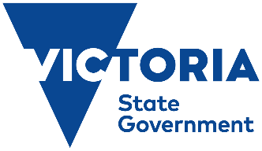 | Smoking and vaping advice for parents in different languages  https://www2.education.vic.gov.au/pal/smoking-vaping-ban/resources
 | Alcohol and Drug Foundation: Talking about vaping with young people  https://adf.org.au/talking-about-drugs/vaping/vaping-youth/talking-about-vaping/

For Young People

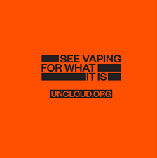 | Uncloud: a resource hub for young Australians 14 – 25 to get everyone to see vaping for what it really is, and to bring together the collective of young people fighting back against vaping.  https://www.uncloud.org/
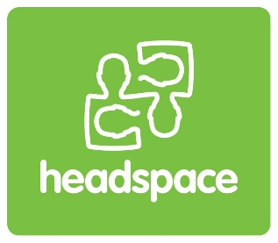 | headspace: young people and vaping - what you need to know  https://headspace.org.au/explore-topics/for-young-people/vaping/
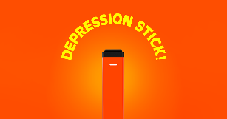 | The Depression Stick: learn the truth about vaping and your mental health.  https://www.thetruth.com/depressionstick

